Analysis of the same data using three different charts.

Choosing the data:-

For creating the three types of charts to do data analysis and the effectiveness of the charts, I wanted to use some real-world data. For this I chose data from google trends about the search history and hits of the last one year on the terms “Data Science” and “Machine Learning”.  
(trends.google.com, n.d.)

Data Wrangling:-

The data directly available was bi-weekly but we wanted monthly data, So we had to aggregate the data to monthly, this made the high level analysis very easy and the charts less crowed.  
(techtrekking.com/, n.d.)

This kind of data aggregating, sometimes cleaning etc. might be always necessary before we start analyzing the data, based on what hypothesis we are trying to answer.

We know from the matplotlib tutorials that pandas data objects may not always work as intended on the plots, so we had to convert them to arrays

Given the data I chose, for me the I would rank the charts is in below order from most effective to least effective.

1. Line Chart – Most effective
2. Bar Chart
3. Pie Chart – Least effective

This does not mean that one chart is better than other, but merely means that for the data I chose to analyze, above it how I would rate it.

Line Chart:-

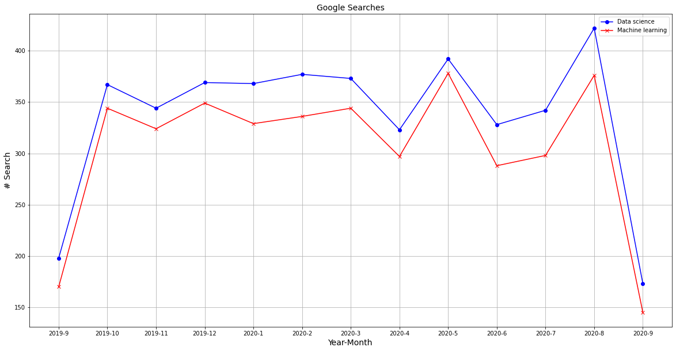  
  
Was very straight forward to create and because of he below reasons is why I have rated it highly effective.

1. Made the search trend across the period of one year on both “Data Science” and “ Machine Learning” very obvious and easily understandable.
2. The compassion of the search of both the terms per month was also made easy and clear. It was very easy to say that all through the year the search on “Data Science” was more than “Machine Learning”.
3. It was also very easy to understand which Month recorded the highest search on each of these terms.

Bar Chart:-  
  
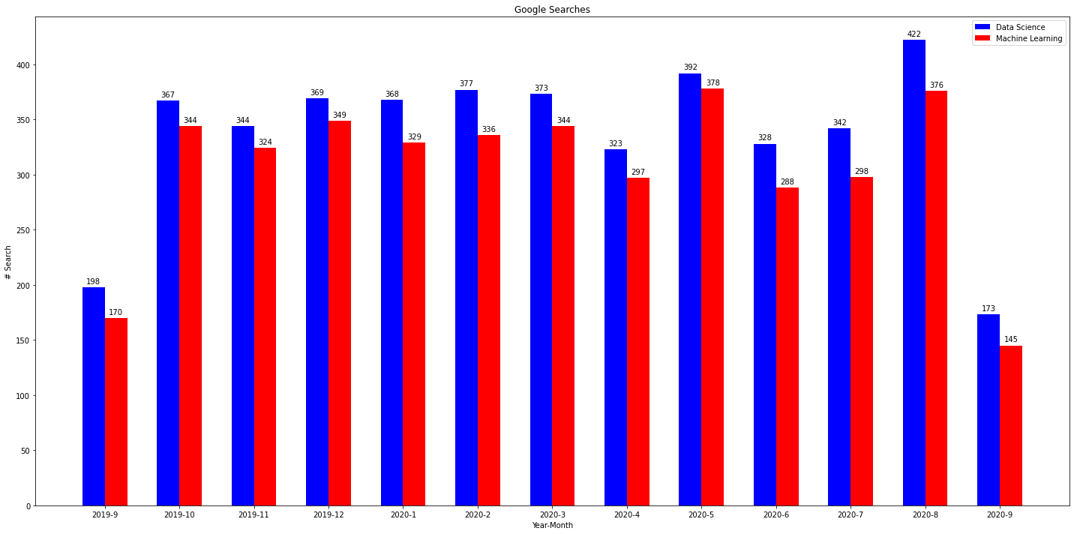

Next we created a bar chart with one bar each for the two search terms per month. This was the second next best effective graph

1. The two bars for each search term per month made the analysis of comparison of the two searches easy, but again this could also be achieved by line chart as well.
2. It was also very easy to understand which Month recorded the highest search on each of these terms though we had the same easiness of that analysis in Line chart as well.

Pie Chart:-

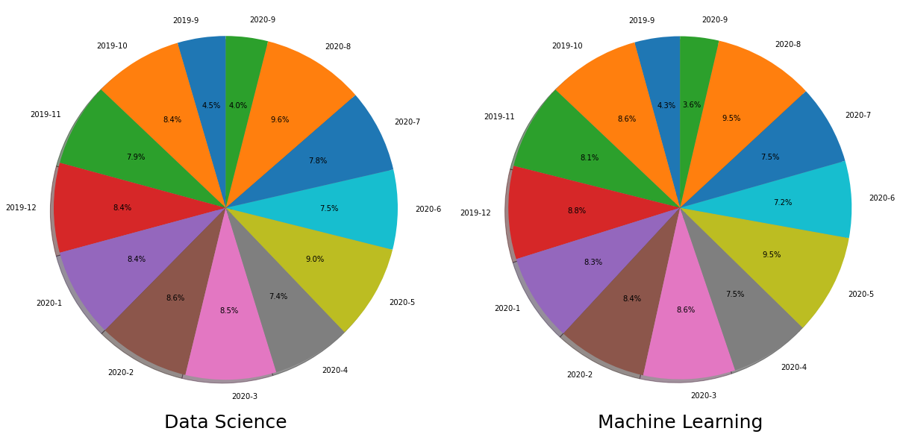

We have seen Pie chart being very useful way of representation of the data in many cases, but in this case, given the type of the data and analysis we are performing, Pie Chart did not make the analysis any easy of the output, the Pie chart came out crowded with data with very little to no information being able to be deduced from the charts.

# Bibliography

*techtrekking.com/*. (n.d.). Retrieved from https://www.techtrekking.com/how-to-convert-daily-time-series-data-into-weekly-and-monthly-using-pandas-and-python/

*trends.google.com*. (n.d.). Retrieved from https://trends.google.com/trends/explore?geo=US&q=%2Fm%2F0jt3_q3,Machine%20learning